**Spark Installation Guide (Windows)**

**1. Installation of Java and Python necessary:**

* Java Download:
* <https://www.oracle.com/java/technologies/java-se-glance.html>

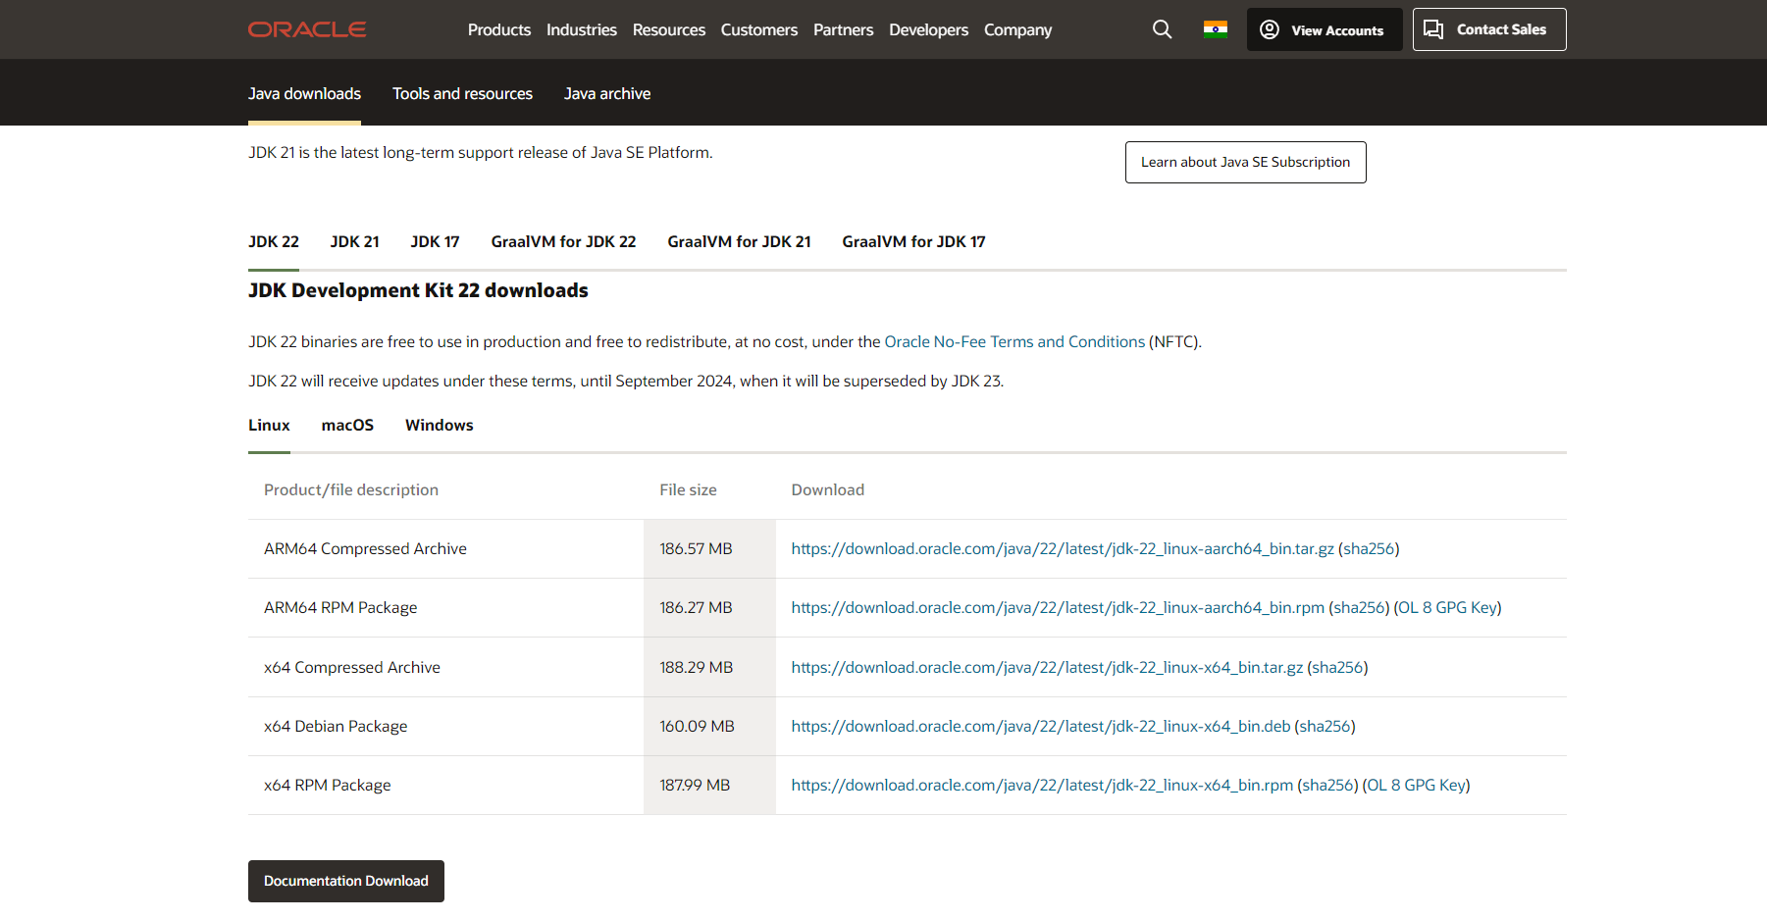

**2. Check Python and Java Versions using Windows CMD:**

* java -version
* python –version

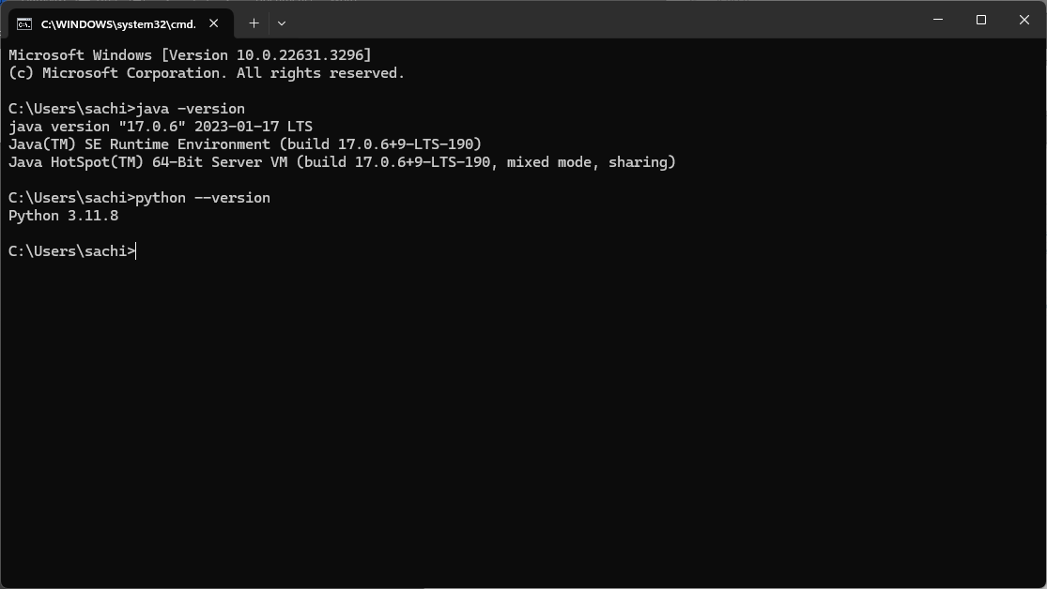

**3. Download Spark Files and copy it in C:/SPARK folder:**

* https://spark.apache.org/downloads.html

Alternatively, we can use direct download link:

* https://dlcdn.apache.org/spark/spark-3.5.1/spark-3.5.1-bin-hadoop3.tgz

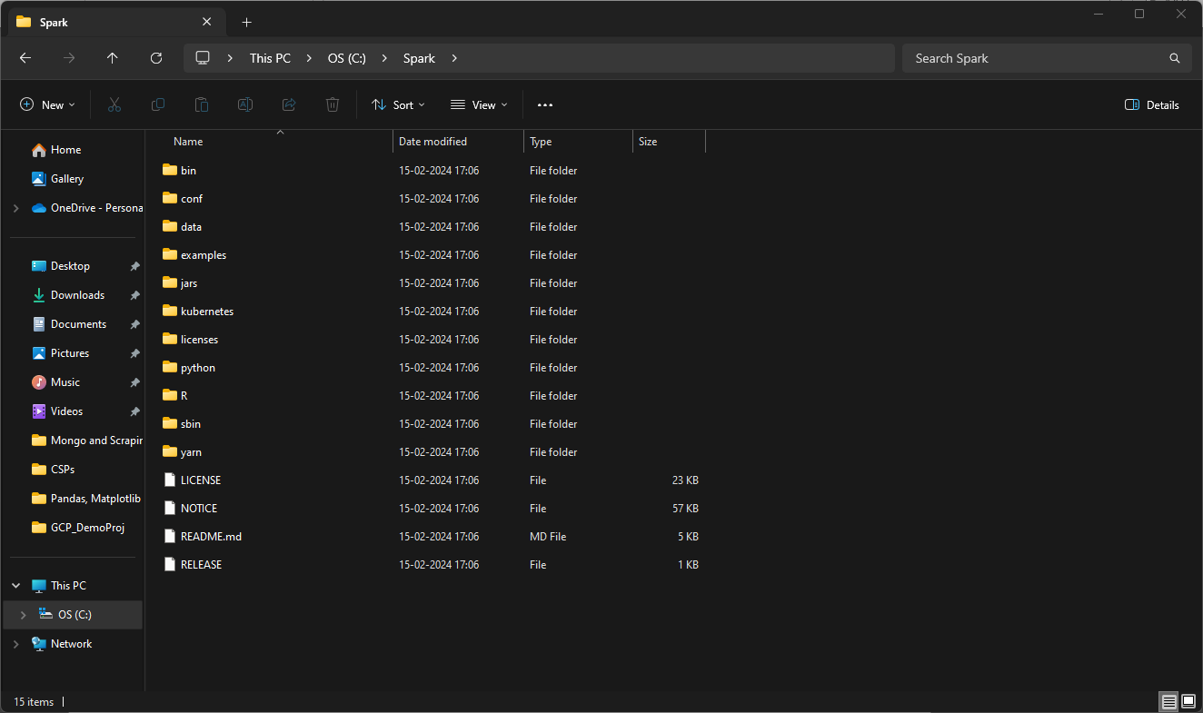

**4. Download WinUtils and copy it in C:/HADOOP/BIN folder:**

* https://github.com/steveloughran/winutils/tree/master/hadoop-3.0.0/bin
* https://github.com/steveloughran/winutils/blob/master/hadoop-3.0.0/bin/winutils.exe
* https://github.com/steveloughran/winutils/blob/master/hadoop-3.0.0/bin/hadoop.dll

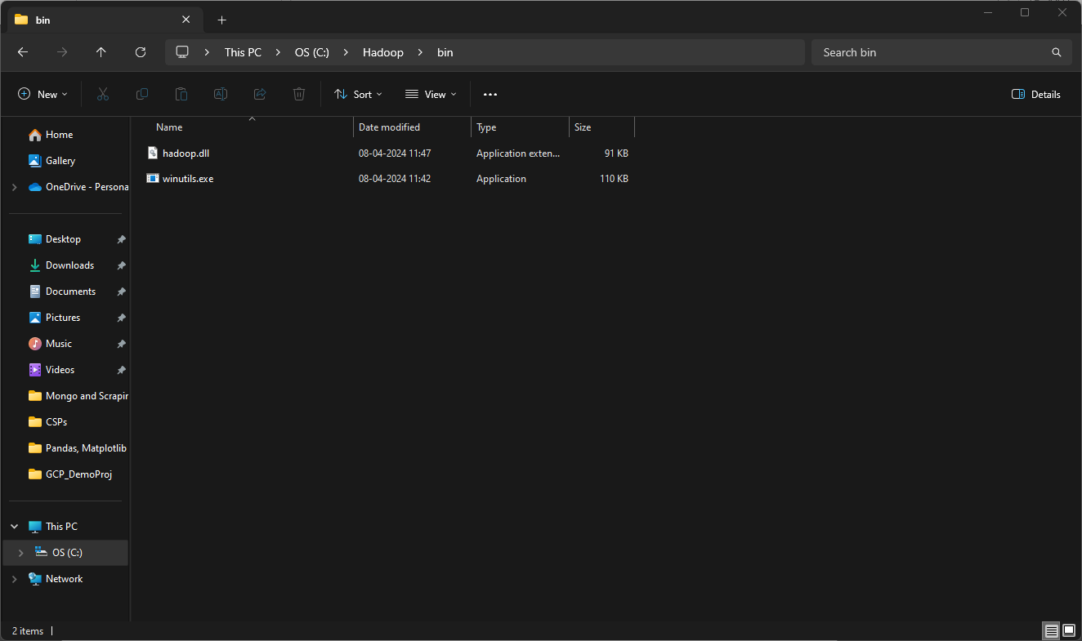

**5. Set the ENVIRONMENT PATH:**

* SPARK_HOME = /**PATH**/
* HADOOP_HOME = /**PATH**/
* SPARK_LOCAL_HOSTNAME = localhost
* PYSPARK_PYTHON = /**PYTHON EXECUTABLE**/
* PYSPARK_DRIVER_PYTHON = /**PYTHON EXECUTABLE**/

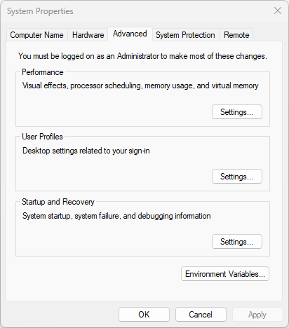

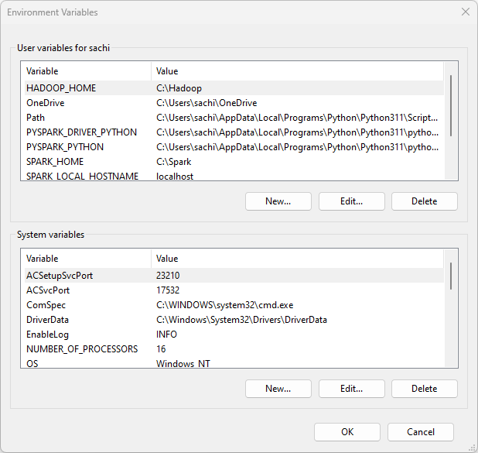

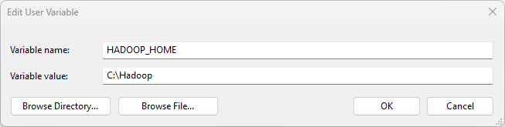

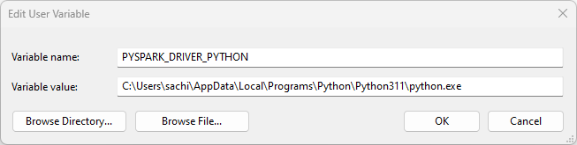

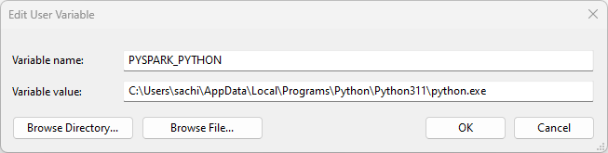

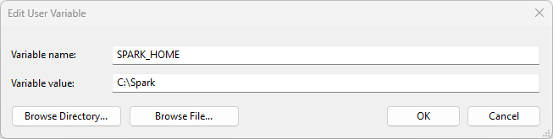

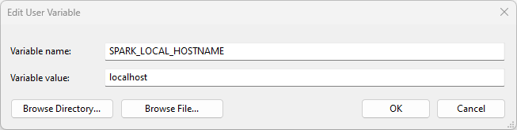

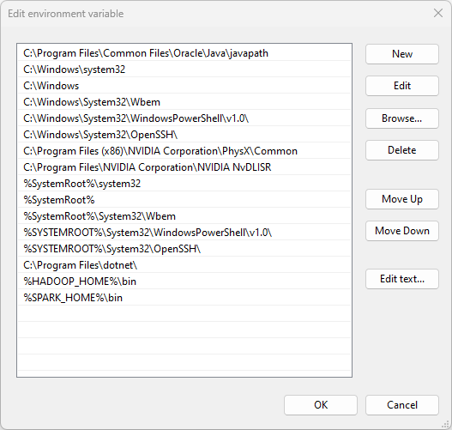

**6. Run Command pyspark in cmd terminal to check if Spark is loaded**

